Is colorectal cancer on your mind? Did you know you can test for it in the comfort of your home with a stool-based test? Wyoming Public Health Nursing offices (PHN) now offer fecal immunochemical (FIT) tests at no cost to you! To find your local PHN office, visit health.wyo.gov/phn-co-offices


A colonoscopy is one of several screening tests for colorectal cancer. Some can even be done from the comfort of your home at a low cost. Talk to your doctor to learn more about getting screened: http://bit.ly/2H1dla2
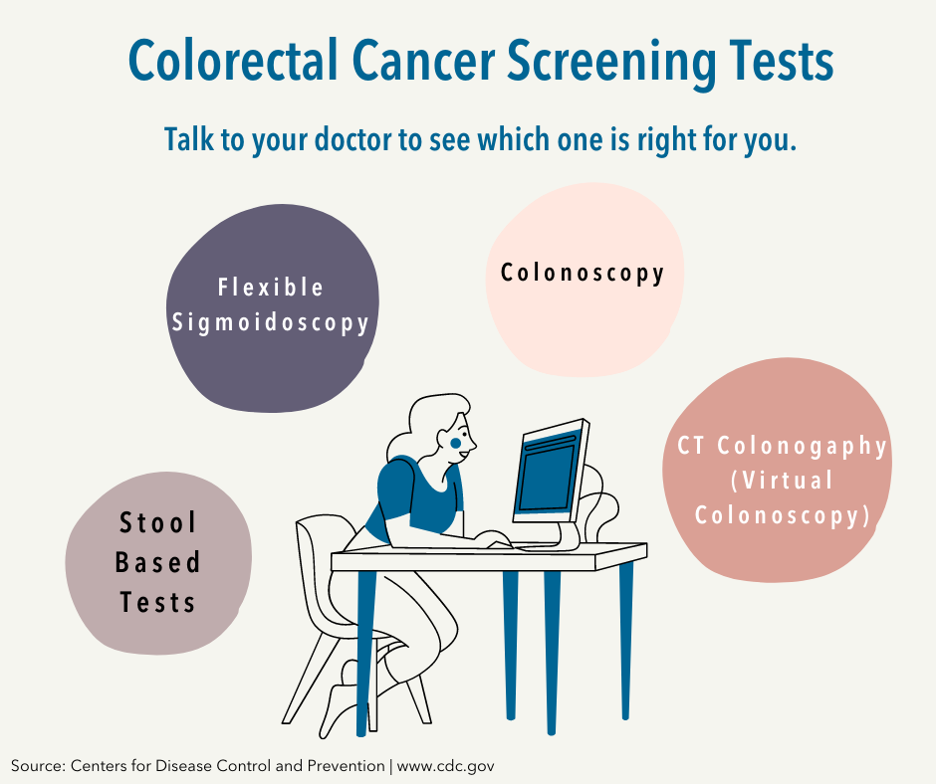

We know having to do a stool-based colorectal cancer screening stinks, but getting colorectal cancer is worse. Early detection is key to catching colorectal cancer early, when it’s easiest treat! And a stool-based test can help! Contact your local Public Health Nursing Office to get a fecal immunochemical (FIT) kit at no cost to you! health.wyo.gov/phn-co-offices


