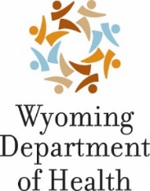 | 122 W 25th St., 4th Floor West • Cheyenne, WY 82002  Phone (307) 777-7531 • 1-866-571-0944  Fax (307) 777-6964 • www.health.wyo.gov | 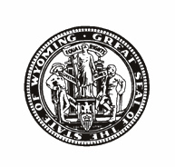
Stefan Johansson Director |  | Mark Gordon  Governor

Medicaid School-Based Services Program
OVERVIEW
On April 1, 2021, Governor Mark Gordon signed into law the Medicaid Billing for School-Based Services Act (SF0079). The new law authorizes school districts to bill Medicaid for school based services for Medicaid eligible students. States have been able to access federal funds for certain health related services since 1998 and Wyoming is the final state to implement this reimbursement program. The SBS Program allows Wyoming to access federal funds for eligible services delivered to Medicaid eligible students with an Individualized Education Program (IEP) or Individualized Family Service Plan (IFSP) in a school-based setting.

School-Based Services Parental/Legal Guardian Consent
In order for the state to receive federal reimbursement, school are required to obtain the consent of the parent/legal guardian of the student receiving the services. The SBS Program will not affect Medicaid coverage, your child's lifetime benefit, or any services your child receives outside of the school setting.
Your child’s school will send the parental/legal guardian consent form to parents/legal guardians for signature. This consent allows for a limited amount of information to be shared with Wyoming Medicaid, including:
- Your child’s name;
- Your child’s Medicaid recipient number, and birth date;
- The service code (numerical code that identifies the service’s provided); and
- The service time spent with your child (number of minutes).

Parents are responsible to complete and return the parental/legal guardian consent form to their child’s school. Consent is voluntary, parents/legal guardians have the right to withdraw consent at any time, and consent is not required for your child to receive special education and related services.

