Opioid vulnerability Assessment

wyoming

prepared by

the department of public health and community medicine at the
tufts university school of medicine
in collaboration with the
wyoming department of health

January 2021





The Council of State and Territorial Epidemiologists provided technical assistance to Wyoming’s Jurisdiction-Level Vulnerability Assessment through Tufts University. The Vulnerability Assessment project and associated technical assistance was funded through the Centers for Disease Control and Prevention’s National Center for Injury Prevention and Control, Cooperative Agreement Number 1NU1ROT000018-01-00. The findings are those of the consultants and do not necessarily represent the views of the Centers for Disease Control and Prevention.

Recommended citation: Pustz J, Shrestha S, Newsky S, Anderson D, Fowler L, Taylor M, Lingwall, C, Van Handel M, and Stopka TJ. Wyoming Opioid Vulnerability Assessment, January 2021.

For questions about this report, contact:
Cailyn Lingwall, MPH
clingwall@cste.org
Council of State and Territorial Epidemiologists

acknowledgements:
The Tufts team would like to thank the following individuals for their contributions to this vulnerability assessment:
Debi Anderson, CPM
Leslie Fowler, BSN, RN
Sarah Newsky, MPH
Melissa Taylor, MPH
Cailyn Lingwall, MPH, CHES
Michelle Van Handel, MPH

Table of Contents
Executive Summary 4
Background 5
Methods 7
Results 12
Discussion 22
References 25
Appendix 28

Executive Summary
The opioid overdose crisis has been one of the most significant challenges to public health in the United States in decades. Fatal overdose rates associated with opioids steadily increased nationwide beginning in 1999, following the introduction of prescription opioid pain relievers. Overdose related to prescribed opioids began leveling off by 2010, only to be followed by major increases in deaths attributed to heroin, followed by fentanyl’s appearance in the illicit drug supply, which caused a much sharper increase in mortality beginning in 2013.^{1,2} Overall, nearly 450,000 people died of an opioid-related overdose between 1999 and 2018,³ and signs of significant increases in opioid-related overdoses and accidental deaths have been noted during the early stages of the SARS-CoV-2 (COVID-19) pandemic in 2020.⁴
Although the opioid epidemic is a public health issue of national concern, the rate of all opioid-related fatalities in Wyoming is considerably lower than the most recent reported national rate. CDC data indicate that in 2018 there were 66 total fatal drug overdoses in the state of Wyoming, of which 40 involved opioids. Of those 40 deaths, 28 (6.8 per 100,000) involved prescription opioids (4.6 per 100,000).⁵
In 2020, a team comprised of researchers from the Department of Public Health and Community Medicine at the Tufts University’s School of Medicine collaborated with staff from the Wyoming Department of Health (WY-DOH), the Centers for Disease Control and Prevention (CDC), and the Council of State and Territorial Epidemiologists (CSTE) to conduct an assessment of opioid overdose vulnerability. We created a series of risk maps to visually describe the spatial distribution of core measures and covariates associated with opioid-related mortality. Core measures included rates of opioid-related overdose, chronic hepatitis C virus (HCV) among individuals under 36 years, opioid prescriptions, drug-related crime and per capita income. Our covariates included socioeconomic and demographic data from the American Community Survey.⁶ Using these same indicators, we calculated composite vulnerability scores to identify counties at higher risk for opioid-related fatalities and associated infections from injection drug use. We also mapped the location of substance use treatment and prevention assets by county and conducted drive-time and population-based accessibility analyses to identify locations where vulnerability to opioid overdose death was high but access to treatment was limited.
Our findings identified Hot Springs, Carbon, Natrona, Fremont, and Sweetwater counties to be the most vulnerable to opioid-related outcomes. Although these counties typically had more services and shorter driving times (Carbon and Sweetwater are also closer to out-of-state services) there appear to be unmet needs tied to opioid-related treatment services. Higher rates of opioid prescribing in these vulnerable counties may also indicate a need for education and outreach related to potentially inappropriate prescribing. Interventions that reduce opioid prescribing and increase access to treatment and harm reduction services have the potential to prevent and protect Wyoming citizens from opioid overdose and associated outcomes.

Background
The opioid overdose crisis, attributed to the use of prescription opioids, heroin, and synthetic opioids (e.g., fentanyl), has been one of the most significant challenges to public health in the United States in decades. Fatal overdose rates associated with opioid use steadily increased nationwide beginning in 1999, following the introduction of prescription opioid pain relievers. Overdoses related to prescribed opioids began leveling off by 2010, only to be followed by major increases in deaths attributed to heroin, followed by fentanyl’s appearance in the illicit drug supply, which caused a much sharper increase in mortality beginning in 2013.¹ The U.S. Centers for Disease Control and Prevention (CDC) reported a record number of overdose deaths in 2016 (63,632, an age-adjusted rate of 19.8 per 100,000 population), of which two-thirds (66.4%, 42,249 deaths) involved an opioid.⁷ Overdose death rates continued to rise in 2017 to 21.7 per 100,000, with 67.8% of those deaths attributed to an opioid.⁸ All told, nearly 450,000 people died of an opioid-related overdose between 1999 and 2018,³ and signs of significant increases in opioid-related overdoses and accidental deaths have been noted during the early stages of the COVID-19 pandemic in 2020.⁴
Although the opioid crisis is a public health issue of national concern, the rate of all opioid-related fatalities in Wyoming is considerably lower than the most recent reported national rate. In Wyoming, as in neighboring western states, stimulant misuse (primarily methamphetamines) has been of greatest concern.⁹ However, when all categories of opioids are combined (prescription and illicit), they account for a higher percentage of overdose deaths than methamphetamines (See Appendix, Figure A-1).^{9,10} According to data from Wyoming Vital Statistics, prescription opioids alone or in combination with illicit drugs have been associated with the majority (66% in 2018) of drug-related deaths in the state over the past two years.¹¹ CDC data indicate that in 2018, there were 66 total drug overdose deaths in the state of Wyoming, 40 that involved opioids, and 28 (6.8 per 100,000) that involved prescription opioids (4.6 per 100,000).⁵
Wyoming’s opioid prescribing rates have been on par with or slightly higher than the national average over the past ten years.¹² In 2018, the opioid prescribing rate per 100 persons in Wyoming was 57.1 for all opioids, compared to the national prescribing rate of 51.4 (Table 1). Wyoming’s prescribing rates for sub-categories of opioids, such as Long Acting/Extended Release (LA/ER) opioids, are also higher than the national average.¹³

Table 1. Opioid prescribing rates per 100 persons, Wyoming and United States, 2018¹³
 | Wyoming | United States
All opioids | 57.1 | 51.4
LA / ER opioids * | 6.2 | 4.5
< 50 MME ** | 40.8 | 39.7
≥ 50 but < 90 MME | 10.5 | 7.9
≥ 90 MME (high-dose) | 5.8 | 3.9

*LA / ER: Long-Acting / Extended Release opioids
**MME: Morphine Milligram Equivalent

Existing publicly available data and analyses describing opioid use and misuse in Wyoming provided a starting point for understanding factors involved in prescription-opioid overdose in the state. For example, the report authored by Rodney Wambeam and colleagues for the Wyoming Survey & Analysis Center (WYSAC), “Telling the Story of Prescription Opioid Use in Wyoming” (2018), described opioid use and the potential for misuse in the state, compared to the nation as a whole, based on data for the years prior to those used in this analysis.
Building upon these resources and recent data related to opioid overdose risk in Wyoming, this report summarizes the findings of a comprehensive opioid-related vulnerability assessment to identify counties in Wyoming at increased risk for opioid overdose and associated outcomes (e.g., infectious diseases from injection drug use).

Methods
Collaborative Efforts. Our collaborative team of researchers and public health experts from the Tufts University School of Medicine, the Wyoming Department of Health (WY-DOH), the Centers for Disease Control and Prevention (CDC), and the Council of State and Territorial Epidemiologists (CSTE) held biweekly videoconferences to discuss opioid vulnerability assessment goals and plans, define outcomes and covariate measures of interest, identify relevant data sources, discuss risk mapping, spatial and statistical analyses, and update the status of deliverables.
Data Sources. We compiled county-level aggregated, de-identified data related to opioid-overdose mortality and a wide range of covariates. We compiled these data for the most recent years for which they were complete: 2016-2018. However, due to suppression of small case numbers for several Wyoming counties, we used data from a longer time frame (2008-2018) for our outcome measure, opioid-related overdose fatalities, to allow for more robust analysis. We downloaded demographic and socioeconomic data from the U.S. Census Bureau’s American Community Survey (ACS) 2014-2018 five-year estimates.⁶ We used ACS population estimates to calculate rates when the rates were not provided by WY-DOH.
We also compiled addresses for substance use treatment and mental health services, medication for addiction therapy (MAT) services, naloxone retailers, and drug-take-back locations from WY data sources and the Substance Abuse Mental Health Services Administration (SAMHSA) online treatment locator. We compiled, geocoded, and mapped these addresses to assess access. We also compiled buprenorphine prescription capacity data through WY-DOH and the U.S. Drug Enforcement Administration (DEA). Finally, we downloaded shapefiles from the Health Resources and Services Administration (HRSA) identifying Health Professional Shortage Area (HPSA) boundaries.
Unit of Analysis. We used the county as the unit of analysis (n=23) for the majority of risk maps and all calculations related to the vulnerability scores and rankings. For some sociodemographic measures, such as per capita income, we mapped census tracts in the Wind River Reservation, but these data were used only in descriptive maps and were not part of the vulnerability scores. Wind River Reservation is made up of over 2 million acres, primarily in Fremont County and a small portion of Hot Springs County; we were not able to disaggregate the data to include Wind River as a separate unit within the vulnerability rankings. We also used census tracts as the unit of analysis for a 2-step floating catchment area (2SFCA) analysis described below. Finally, we mapped the spatial distribution of buprenorphine prescription capacity by ZIP Code, which was the unit in which these data were provided. These data were not included in the weighted ranks.
Measures. Core: We used five core indicators in the spatial and statistical analyses, based on previous publications and subject matter expertise from CDC and CSTE.¹⁴ These included: opioid-related overdose deaths, drug-related crime, retail opioid prescriptions dispensed, per capita income, and chronic hepatitis C virus (HCV) rates for individuals <36 years of age (as a substitution for acute HCV).
Covariates. We compiled the following covariates and contextual measures based on those selected for prior jurisdiction-level opioid vulnerability assessments and previously published reports and studies (Table 2).^{14–16}
Table 2. Core and covariate measures for the Wyoming opioid vulnerability assessment.
Measure | Years | Source
Core
Opioid overdose death rate (per 100,000 population) | 2008-18 | Wyoming Department of Health
Drug-related arrest rate (per 100,000 population) | 2016-19 | Alcohol and Crime in Wyoming, 2016-19. Wyoming Association of Sheriffs and Chiefs of Police.
Chronic hepatitis C virus diagnoses under age 36 years (per 100,000 population) | 2015-19 | Wyoming Department of Health
Retail opioid prescription rates (per 100 population) | 2018 | CDC, https://www.cdc.gov/drugoverdose/maps/rxrate-maps.html
Per capita income | 2014-28 | American Community Survey (ACS) five-year estimates
Covariates
Percent of households that are renters | 2014-18 | American Community Survey (ACS) five-year estimates⁶
Percent of married couple households | 2014-18 | American Community Survey (ACS) five-year estimates
Percent of female-led households | 2014-18 | American Community Survey (ACS) five-year estimates
Percent of population that is uninsured | 2014-18 | American Community Survey (ACS) five-year estimates
Percent of population that does not have a vehicle | 2014-18 | American Community Survey (ACS) five-year estimates
Percent of population that is non-Hispanic White | 2014-18 | American Community Survey (ACS) five-year estimates
Percent of population that is male | 2014-18 | American Community Survey (ACS) five-year estimates
Gini index (measure of wealth inequality) | 2014-18 | American Community Survey (ACS) five-year estimates
Percent of population without internet access | 2014-18 | American Community Survey (ACS) five-year estimates
Non-fatal drug poisoning hospitalization rate (per 100,00 population) | 2016-18 | Wyoming Department of Health
Non-fatal drug poisoning ER visit rate (per 100,000 population) | 2016-18 | Wyoming Department of Health
County located in a High-Intensity Drug Trafficking Area | 2019 | https://rmhidta.org/

Dataset. We incorporated the core measures and potential covariates into one spreadsheet for import and analysis within a geographic information system (GIS) and a statistical software package. Wyoming counties were listed in the rows and outcome/covariates in the columns. We compiled all prevention and treatment asset information at the address level in separate Excel spreadsheets. Data for drug overdose (all drugs and opioid-related) had missing values due to suppression of data for counties with less than five outcomes. Data for non-fatal drug poisoning (hospitalization and emergency room visits) had missing values due to suppression and hospitals that do not contribute to the Wyoming Hospital Discharge Dataset.
Joining and Geocoding. Using the dataset described above, we joined the tabular data for core measures and covariates with a Wyoming county boundary file (i.e., shapefile). We used the ESRI World Geocoding Service to geocode addresses for prevention and treatment assets, obtaining a 100% match rate. We used ArcMap 10.7.1. (ESRI, Redlands, CA) for basic geoprocessing tasks (geocoding and joining tables and shapefiles).
Descriptive mapping. We developed a series of thematic risk maps, within the GIS, to depict the spatial distribution of all core measures and salient sociodemographic variables across Wyoming counties. We also developed a series of descriptive maps using the address points to portray the spatial landscape for Wyoming with regard to access to hospitals, substance use treatment centers, and related services. For measures that included missing data, we used the following methods for creating descriptive maps. Counties with suppressed counts were assigned counts of three and rates were calculated based on the county population estimate provided by WY-DOH. We used three, the median of known counts from zero to five. Counties for which hospital discharge data were not available were not assigned values and mapped as “no data provided.”
Network Analysis: Drive-Time Buffers. In addition to development of descriptive maps to depict the locations for substance use treatment providers and centers across the state, we used two spatial analytical approaches to better understand access to services. We calculated drive-times, based on street networks and speed limits across Wyoming to develop 15, 30, 45, 60, and 120-minute drive-time buffers, using cut-points recommended by WY-DOH staff. We developed separate drive-time maps for MAT providers/treatment centers and opioid treatment programs (OTPs), and added a layer that outlined the counties at highest risk for opioid-overdose mortality based on our vulnerability rankings. We calculated drive-time buffers in ArcGIS Pro 2.5 (Esri, Redlands, CA).
Accessibility to Treatment: 2-Step Floating Catchment Area Analysis (2SFCA). We also measured access to buprenorphine treatment services using a 2SFCA analysis.
The 2SFCA method builds on the provider-to-population ratio (number of providers divided by population in a specified region) by removing administrative boundaries and creating an accessibility index based on drive time.^{17,18} We performed this analysis in two steps:
- First, we calculated the provider-to-population ratio for all populations that were within a 45-minute drive-time threshold distance from the provider location.
- Second, we added the provider-to-population ratios of all the providers that were within a 45-minute drive time of each census tract population centroid.
The model we employed was expressed as follows:
$A_{i}= \sum_{j=1, d<D}^{n}{\frac{S_{j}}{\sum_{k=1, d<D}^{m}{P_{k}}}}$
Where, S_{j} was the number of providers at location j; d was the drive-time between the provider and the population centroid; P_{k} was the population of location k, where the centroid of the census tract was located within the threshold distance; D was the threshold distance for the search radius; and A_{i} was the accessibility score at location i.
We utilized an Open-Source Routing Machine for calculating drive-time between provider and population centroids using a 45-minute drive-time threshold distance to generate a spatial accessibility index. Recently published information reported an average 48 drive-time to opioid treatment program in rural census tracts.¹⁹ Our recommendation of using 45-minute drive-time threshold was further supported by the stakeholders in Wyoming. As the data for buprenorphine capacity (i.e., number of treatment slots) for each provider was not available, we assumed that the number of providers at each location was constant across all sites and assigned it a value of 1. We conducted the spatial analysis using R 4.0.2 (Vienna, Austria).
Analysis, Vulnerability Scores, and Ranking. We used a weighted ranks approach to calculate vulnerability scores, ranking counties from most to least vulnerable (Figure 1). First, we calculated correlation coefficients to determine the direction and strength of association between fatal opioid overdose and each of the five core measures and the covariates listed in Table 2. Next, we assigned quintile ranks to all core measures and covariates by county, with 5=high and 1=low. We flipped the ranks for per capita income and percentage of married couple households, which typically have a negative (or inverse) association with opioid vulnerability. For example, high per capita income is typically protective; therefore, the lowest quintile for per capita income was assigned a rank of five. Next, we multiplied the quintile rank for each core measure by three given their stronger association with opioid overdose, based on the literature. We summed the weighted quintile ranks for each county to calculate the vulnerability score. We then sorted vulnerability scores from highest to lowest to assign final ranks. We mapped the ranks according to quintiles and created a table displaying the vulnerability scores and ranks by county.

Figure 1. Steps in the weighted ranks method of opioid vulnerability assessment, Wyoming, 2016-2018.

Results
Descriptive Mapping and Weighted Ranks Analysis. Our descriptive maps of core measures and quintile rankings of covariates offered insight into the spatial distribution of individual contributors to opioid-overdose vulnerability and highlighted counties that ranked high in multiple risk factors.
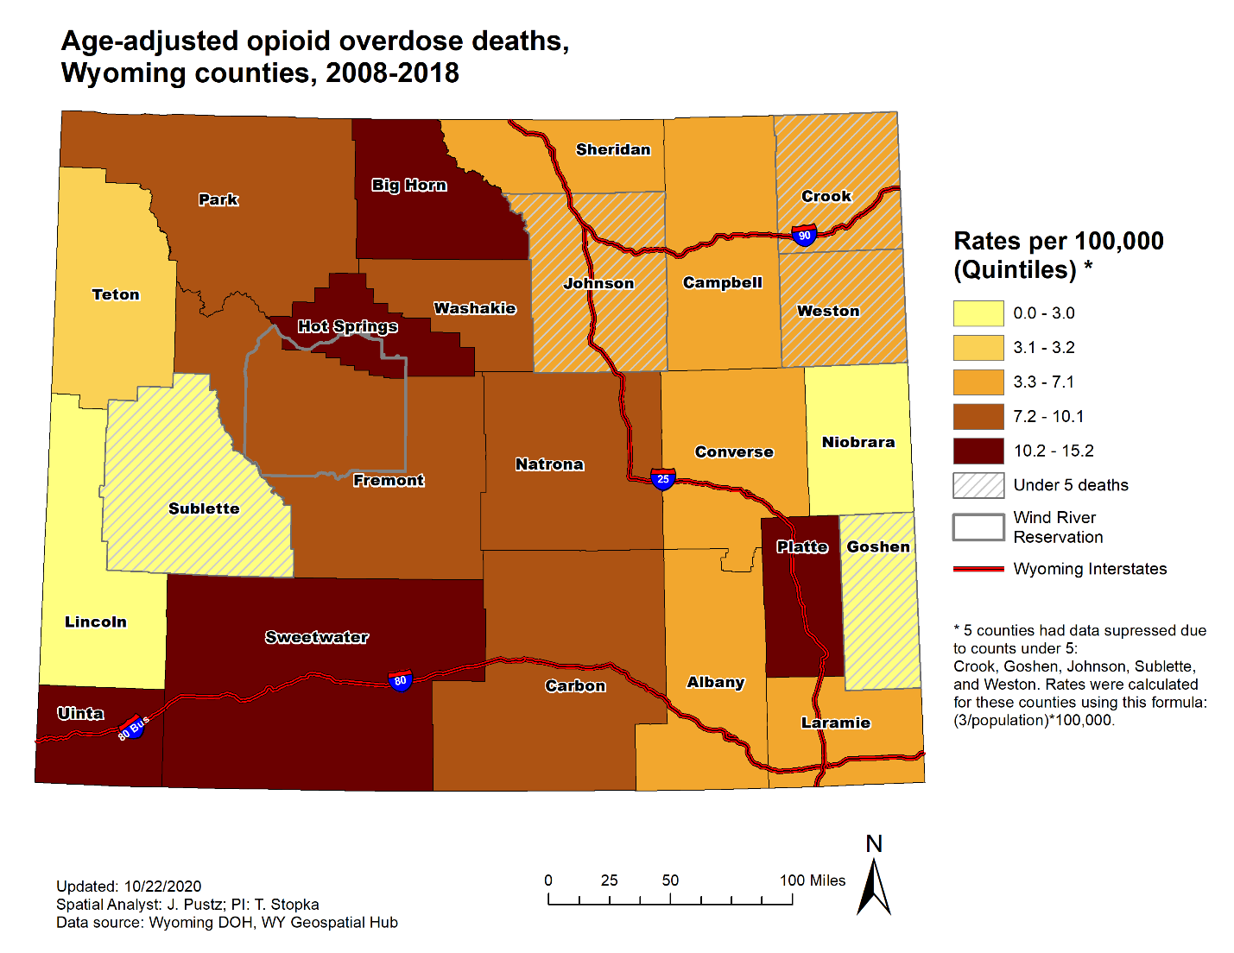
Core measures. The rate of opioid overdose deaths by county (Figure 2) had similar spatial distributions as the number of retail opioid prescriptions dispensed (Figure 3). For both measures, Uinta, Sweetwater, and Hot Springs Counties ranked in the highest quintile (most vulnerable), with the Hot Springs-adjacent Washakie County ranking in the upper quintile for opioid prescriptions, and Big Horn County (adjacent to Washakie) ranking in the upper quintile for opioid overdose deaths. Platte County, in eastern Wyoming, also ranked in the highest quintile for opioid overdose deaths. Counties adjacent to Platte ranked in the highest quintile for drug-related arrests and were located on the state’s primary north-south interstate highway (Figure 4).
Figure 2. Age-adjusted opioid overdose death rate per 100,000 population, Wyoming, 2008-2018.

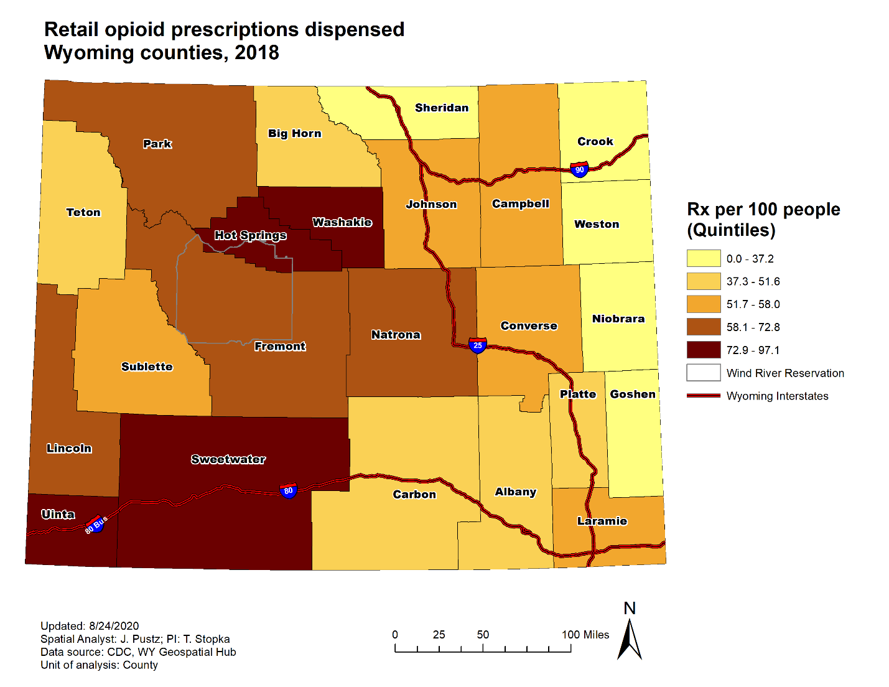

Figure 3. Number of retail opioid prescriptions dispensed per 100 population, Wyoming, 2018.
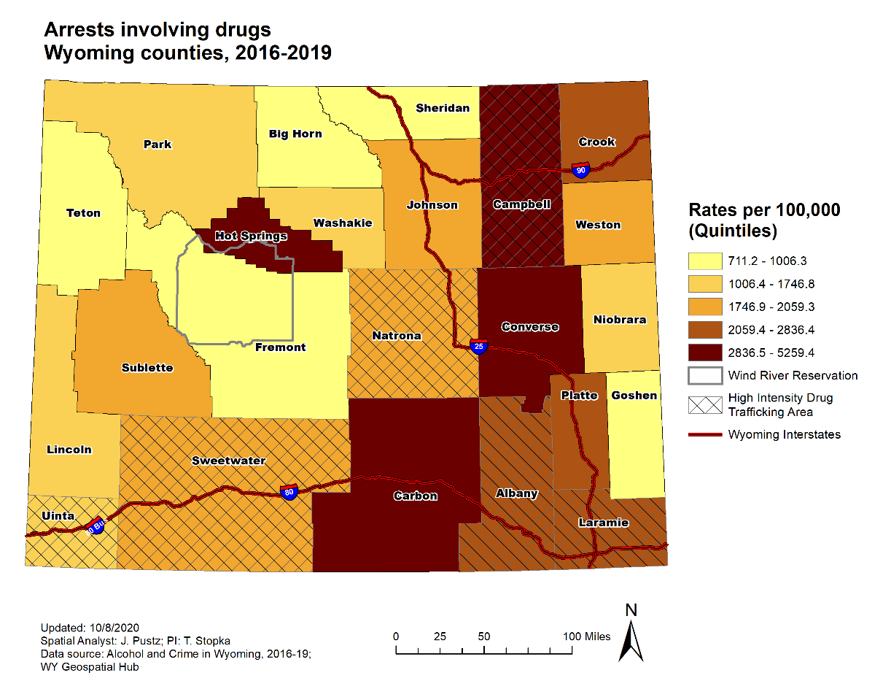

Figure 4. Drug-related arrest rate per 100,000 population, Wyoming, 2016-2019.

Covariates. We created maps for twelve covariates that are commonly associated with opioid-related outcomes in the scientific literature. Two counties most vulnerable to opioid-related mortality, Hot Springs and Sweetwater, also had among the highest rates of non-fatal drug poisoning Emergency Room visits (for both all drugs and opioids specifically) (Figures 5 and 6.). Among other counties that ranked in the upper quintile for non-fatal drug overdose, Washakie County also had high rates of residents who were unemployed and uninsured and Uinta County ranked in the upper quintile for percent of residents with a disability and percent unemployed. Although arrests involving alcohol and involving methamphetamine were not included in the weighted rank analysis, maps for this measure depicted Hot Springs County in the upper quintile (See Appendix). A map of prevalence of people living with HIV indicated that Hot Springs and Washakie, counties with high rates of opioid prescription and opioid overdose deaths, were in the bottom quintile for HIV prevalence (See Appendix).
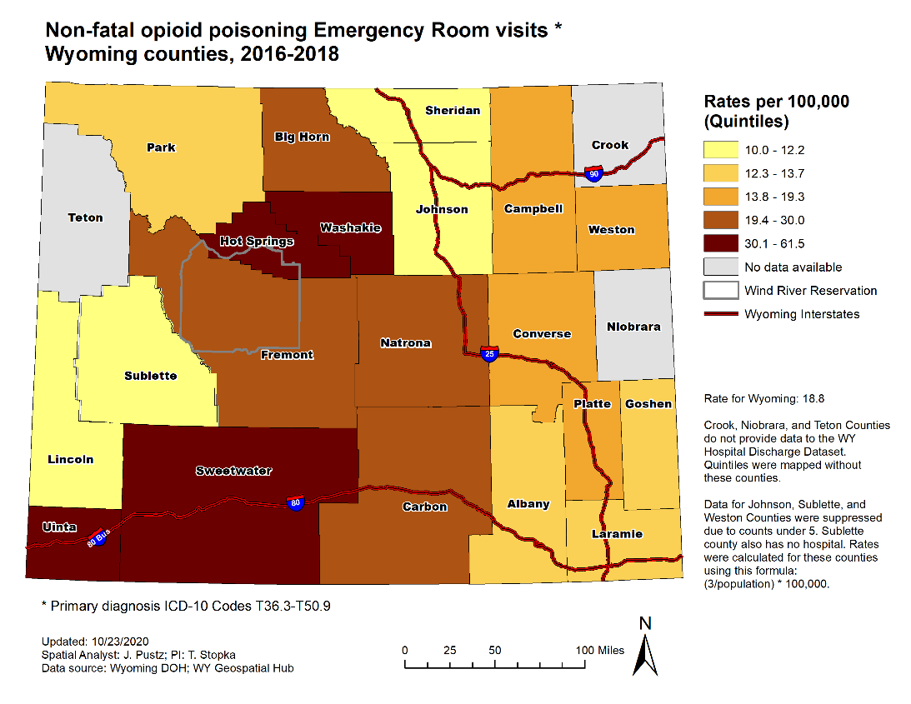

Figure 5. Non-fatal opioid-related drug poisoning ER visit rates per 100,000 population, Wyoming, 2016-2018.

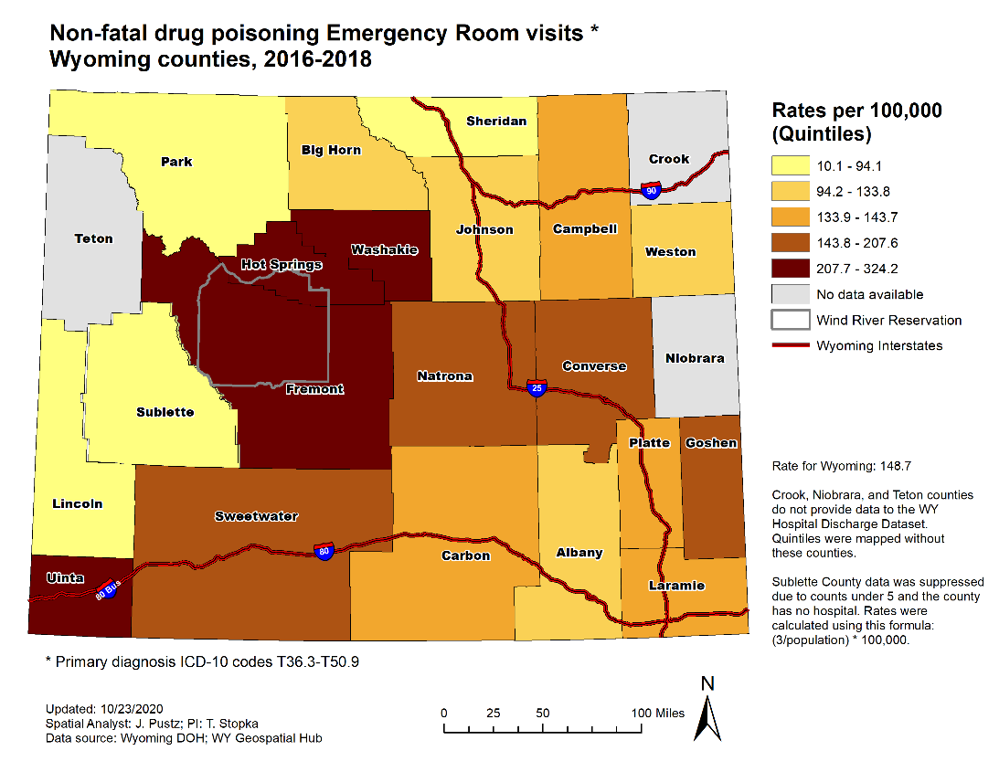

Figure 6. Non-fatal drug poisoning ER visit rates, all drugs, per 100,000 population Wyoming, 2016-2018.
Asset maps. Our maps of geocoded addresses for MAT, mental health treatment, buprenorphine-waivered physicians, drug take-back sites, and locations where naloxone may be obtained, indicated that higher density and diversity of services for people with opioid use disorder (OUD) were primarily located in the more populous counties (Figure 7). Naloxone and drug take-back sites were the most common assets and could be found in all counties. See appendix for maps of specific assets.
In addition to the location and distribution of services specifically related to substance use and misuse, we also mapped locations for general healthcare services. Data related to Health Professional Shortage Areas indicate that all but nine counties were designated as having some level of healthcare shortage. (See Appendix). Only four regional or area trauma centers (two of each) exist in the state (See Appendix).

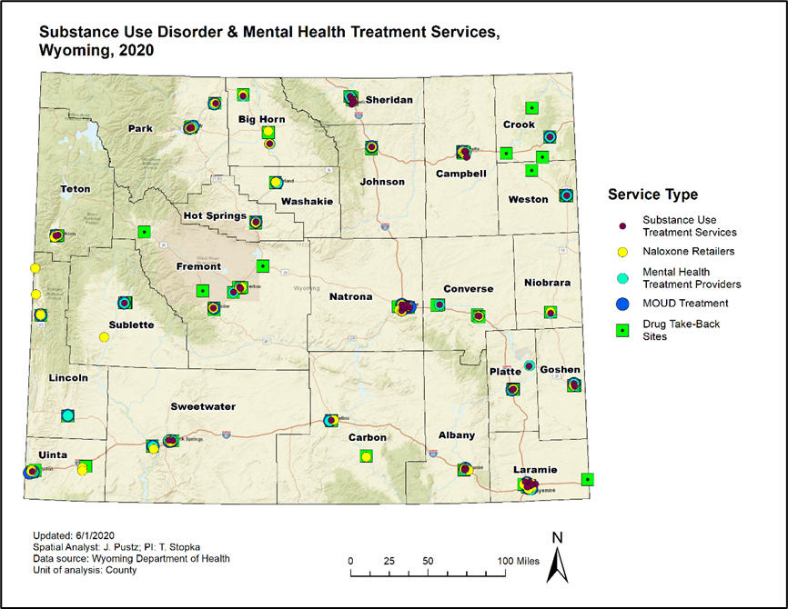
Figure 7. Substance Use Disorder and Mental Health Treatment and supports, Wyoming, 2020.

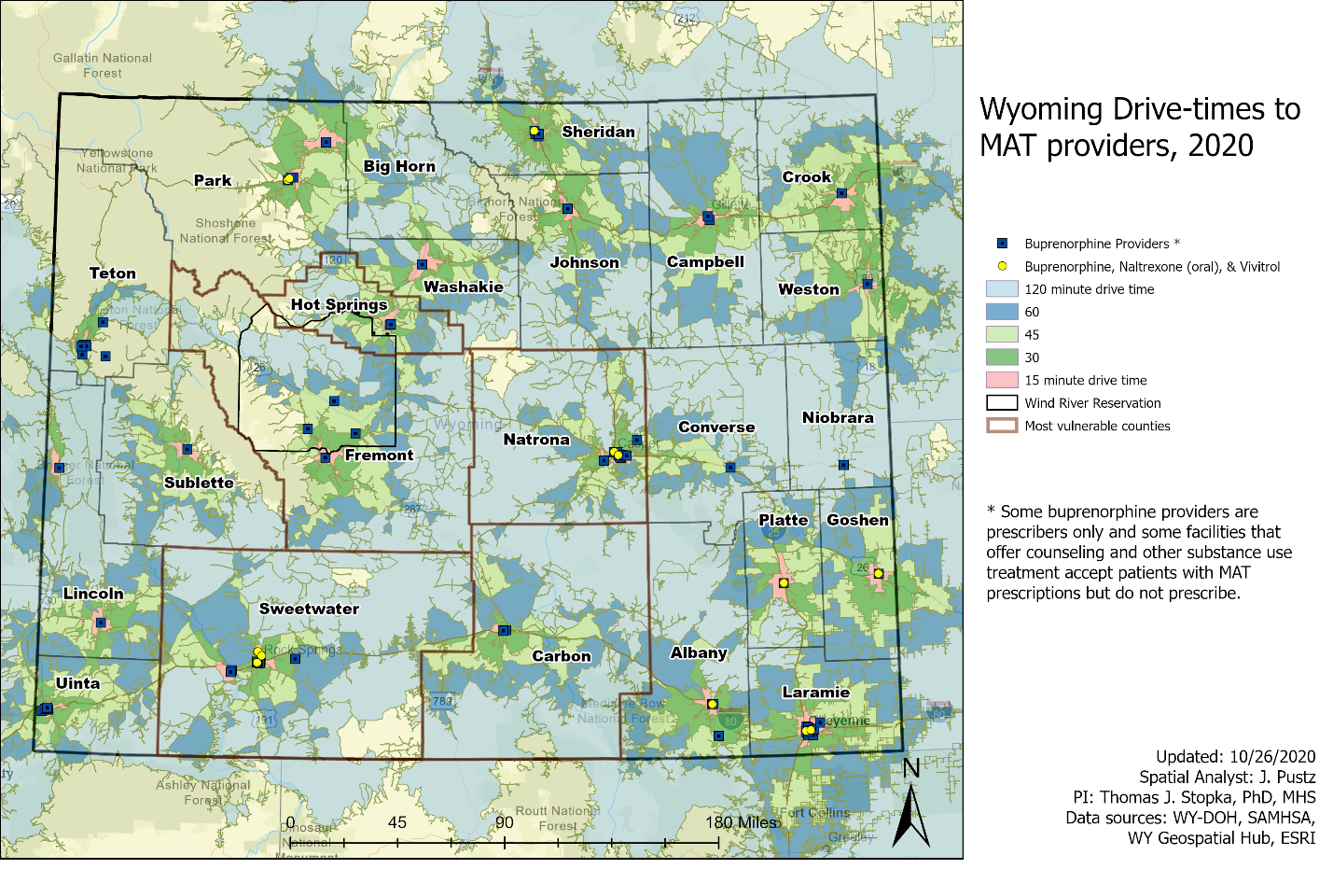
Network analysis. Through our network analyses, we found that 60-120 minute drive-times to buprenorphine and/or naltrexone treatment services were likely for people with OUD in much of Wyoming (Figure 8). According to the SAMHSA treatment directory, not all substance use treatment locations provide prescriptions for MAT, although they accept patients who obtain prescriptions elsewhere.
Figure 8. Drive times to MAT providers and treatment, Wyoming, 2020.
Wyoming does not currently offer methadone maintenance as an option for treatment. The nearest SAMHSA-certified methadone maintenance programs, are located in adjacent states, well over a four-hour round trip by car (Figure 9). Syringe services programs (SSPs), which typically provide needle exchange and a wide variety of testing and wrap-around services, are illegal in Wyoming.
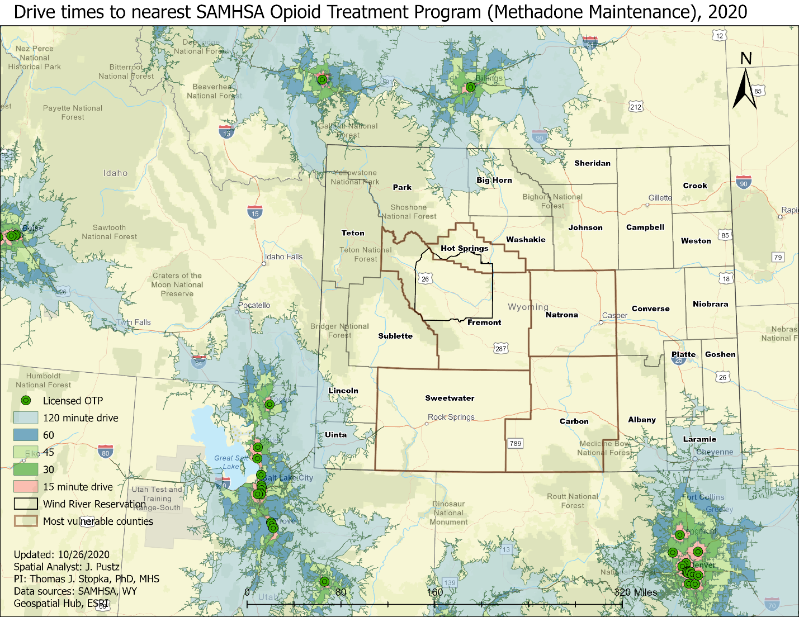
Figure 9. Drive times to methadone maintenance programs, Wyoming, 2020.

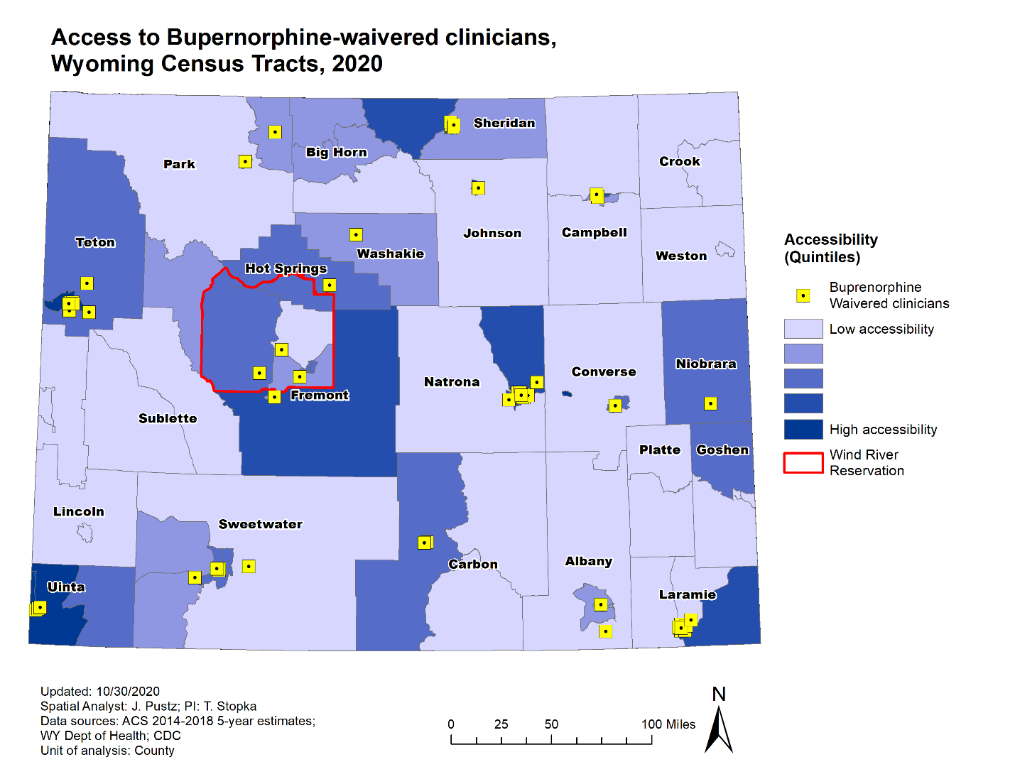
Accessibility to Treatment: 2-Step Floating Catchment Area Analysis. Through 2SFCA analyses, we found that the majority of Wyoming can be described as having low accessibility to buprenorphine-waivered clinicians; the highest areas of access generally being closest to higher populations. The floating catchment area accounts for the distribution of both providers and the underlying population served by them. Therefore, it is likely that some areas with higher number of providers may still have low accessibility as they may serve a large population. This is particularly true in larger cities that have few providers.
Figure 10. Accessibility to substance use treatment using 2SFCA, Wyoming, 2020.

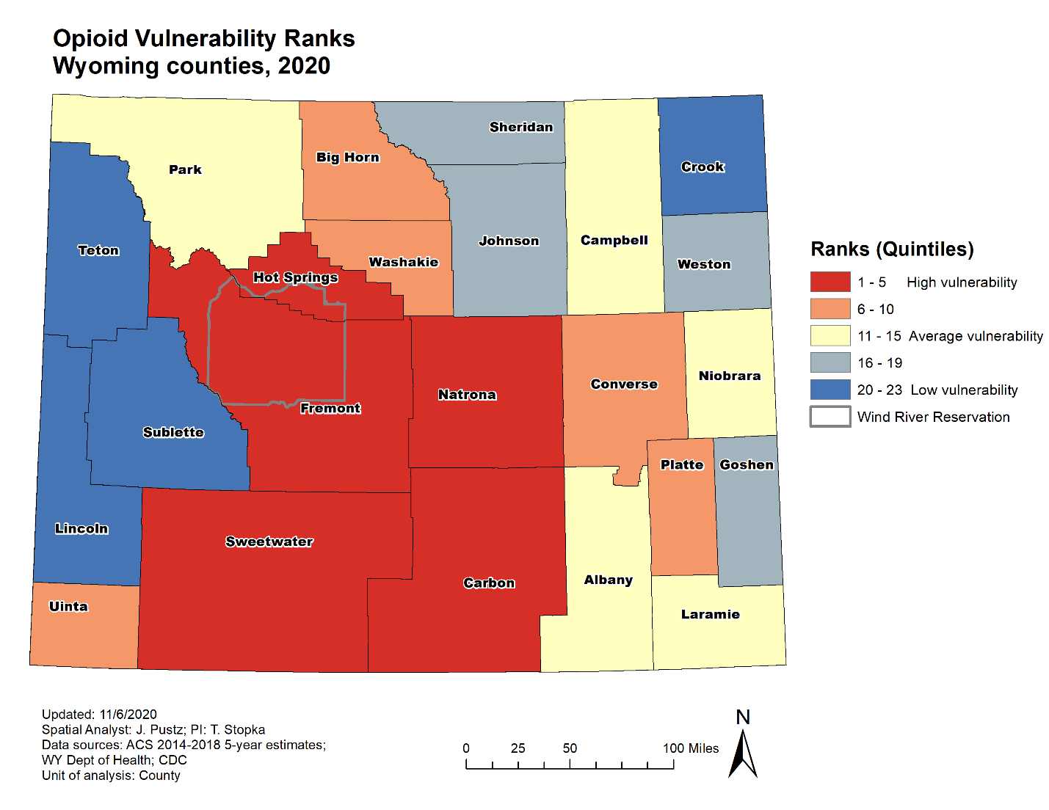
Vulnerability Scores and Ranking. Based on the weighted quintile ranks analysis, we found Hot Springs, Carbon, Natrona, Fremont, and Sweetwater to be most vulnerable to opioid-related overdose death (Table 3, Figure 11). These counties typically ranked highly for core measures and covariates most often associated with fatal opioid overdose. Hot Springs County ranked in the top quintile for all but one core measure (per capita income) and was in the top quintile for non-fatal drug poisoning hospitalizations and ER visits. Hot Springs, Carbon, Natrona, and Fremont ranked in the second highest category for fatal opioid-related overdose but the highest quintile for non-fatal drug poisoning hospitalizations.
Figure 11. Opioid vulnerability ranks, Wyoming, 2020.

Table 3. Opioid vulnerability scores and quintile ranks by county, Wyoming, 2020.
 |  |  | Core Measures |  |  |  |  | Covariates
County | Total Score | Rank | Opioid OD | Chronic HCV | Drug-Related Arrest | Per capita income | Opioid Rx | % Renters | % Married couple HH | % Female-led HH | % Uninsured | % No vehicle | % NH White | HIDTA | % Male | Gini index | % Without Internet | Non-fatal drug poisoning hospitalization | Non-fatal drug poisoning ER visits
Hot Springs | 109 | 1 | 5 | 5 | 5 | 3 | 5 | 2 | 3 | 5 | 2 | 4 | 5 | 1 | 2 | 3 | 3 | 5 | 5
Carbon | 96 | 2 | 4 | 4 | 5 | 4 | 2 | 4 | 4 | 5 | 2 | 2 | 2 | 1 | 5 | 2 | 4 | 5 | 3
Natrona | 96 | 3 | 4 | 3 | 4 | 2 | 4 | 5 | 5 | 4 | 4 | 2 | 3 | 4 | 2 | 4 | 3 | 5 | 4
Fremont | 92 | 4 | 4 | 4 | 1 | 4 | 4 | 4 | 5 | 4 | 5 | 3 | 1 | 1 | 1 | 3 | 4 | 5 | 5
Sweetwater | 87 | 5 | 4 | 3 | 3 | 2 | 5 | 2 | 4 | 4 | 3 | 2 | 2 | 4 | 4 | 2 | 1 | 4 | 4
Uinta | 87 | 6 | 5 | 2 | 2 | 5 | 5 | 2 | 2 | 3 | 3 | 2 | 3 | 4 | 2 | 2 | 1 | 1 | 5
Converse | 82 | 7 | 3 | 4 | 5 | 3 | 4 | 3 | 1 | 1 | 1 | 1 | 5 | 1 | 3 | 1 | 2 | 2 | 4
Big Horn | 81 | 8 | 5 | 4 | 1 | 5 | 2 | 3 | 3 | 2 | 5 | 3 | 4 | 1 | 2 | 1 | 4 | 1 | 1
Washakie | 81 | 9 | 3 | 2 | 2 | 5 | 5 | 1 | 2 | 2 | 5 | 4 | 1 | 1 | 1 | 1 | 3 | 4 | 5
Platte | 80 | 10 | 5 | 1 | 4 | 3 | 2 | 3 | 3 | 2 | 2 | 1 | 4 | 1 | 4 | 5 | 5 | 3 | 2
Niobrara | 78 | 11 | 1 | 5 | 2 | 5 | 1 | 2 | 3 | 1 | 5 | 2 | 2 | 1 | 5 | 4 | 5 | 3 | 3
Park | 78 | 12 | 4 | 5 | 2 | 1 | 4 | 4 | 2 | 2 | 3 | 4 | 3 | 1 | 2 | 4 | 2 | 2 | 1
Albany | 77 | 13 | 2 | 1 | 4 | 5 | 2 | 5 | 5 | 1 | 1 | 5 | 1 | 4 | 4 | 5 | 1 | 2 | 1
Campbell | 77 | 14 | 3 | 3 | 5 | 2 | 3 | 3 | 2 | 3 | 1 | 5 | 4 | 4 | 1 | 1 | 1 | 2 | 2
Laramie | 76 | 15 | 3 | 2 | 4 | 2 | 3 | 4 | 4 | 4 | 1 | 3 | 1 | 4 | 2 | 3 | 2 | 4 | 2
Johnson | 74 | 16 | 2 | 1 | 3 | 1 | 3 | 4 | 4 | 5 | 4 | 5 | 2 | 1 | 5 | 5 | 5 | 2 | 2
Weston | 68 | 17 | 2 | 3 | 3 | 4 | 1 | 1 | 4 | 3 | 4 | 3 | 2 | 1 | 1 | 3 | 4 | 1 | 2
Sheridan | 65 | 18 | 2 | 4 | 1 | 1 | 1 | 5 | 5 | 5 | 1 | 4 | 4 | 1 | 1 | 4 | 3 | 4 | 1
Goshen | 64 | 19 | 1 | 5 | 1 | 4 | 1 | 2 | 2 | 2 | 3 | 1 | 2 | 1 | 4 | 2 | 5 | 1 | 3
Crook | 63 | 20 | 2 | 1 | 4 | 3 | 1 | 1 | 1 | 1 | 2 | 4 | 4 | 1 | 2 | 4 | 4 | 3 | 3
Sublette | 61 | 21 | 1 | 2 | 3 | 2 | 3 | 1 | 1 | 1 | 4 | 1 | 5 | 1 | 5 | 1 | 2 | 3 | 3
Lincoln | 60 | 22 | 1 | 1 | 2 | 4 | 4 | 1 | 1 | 3 | 4 | 1 | 5 | 1 | 2 | 2 | 2 | 1 | 1
Teton | 60 | 23 | 1 | 2 | 1 | 1 | 2 | 5 | 5 | 4 | 2 | 5 | 1 | 1 | 4 | 5 | 1 | 3 | 3
Quintile ranks: 5 = high, 1 = low

Discussion
In this assessment, our team used data representing a range of public health, demographic, and socioeconomic measures to estimate opioid-related vulnerability in the state of Wyoming on the county level. We found that over-prescribing of opioids may be an issue of concern in counties with higher rates of opioid overdose; that non-fatal opioid overdose patterns served as a solid proxy for risk for fatal overdoses, following similar spatial patterns across the state; and that access to treatment for OUD was limited. We identified five counties with high vulnerability levels: Hot Springs, Carbon, Natrona, Fremont, and Sweetwater. Targeted and tailored intervention approaches, which take into consideration each county’s mix of risk and protective factors related to opioid-related injury and mortality, are needed.
First, our vulnerability assessment suggests that prescription opioids may still be an issue of concern in the state of Wyoming. In many regions of the United States, the prescription opioid crisis has abated somewhat, in the wake of new prescribing rules and the implementation of Prescription Drug Monitoring Programs (PDMPs) that require clinicians to check patient prescribing records before prescribing an opioid.^{20,21} While the CDC identified the prescription opioid crisis as the first of three “waves” in the opioid crisis, and an abatement of prescription-opioid related deaths by 2010 in most states,²² our vulnerability assessment suggests that Wyoming may still be experiencing substantial effects of the first wave.
Data from the Wyoming Department of Health Substance Abuse Prevention dashboard indicate that prescription opioids are a major contributor to non-fatal opioid overdose. Between 2016-2018, prescription opioids were responsible for 86 percent of opioid-related emergency room visits and 91.2 percent of opioid-related hospitalizations.²³ Opioid prescribing is highest in Uinta County, where between 2014-2016, there were more retail opioid prescriptions than residents (1,075 per 1,000 population); however, this county is also home to the Wyoming State Hospital, a major provider of treatment for substance use and mental health disorders.¹² Hot Springs (997 per 1,000 population), Park (964), and Washakie (954) round out the top five counties for opioid prescription rates.¹² Diversion and home storage of prescribed opioids in excess of need may need to be addressed statewide. Wyoming does have a wide network of drug-takeback locations, with at least one per county, but at least one recent study indicated that patients lack knowledge about proper disposal of excess medications.²⁴ Wyoming might look to successful interventions piloted in rural communities, such as opioid buy-back programs, to reduce the amount of excess prescription opioids in circulation.²⁵
Second, given the small number of opioid-related overdoses per county, non-fatal overdose, which is more prevalent, is a useful proxy for fatal overdose risk. Wambeam and colleagues documented 737 cases of naloxone administration by EMS in 92,537 ambulance trips over the period of January 1, 2016 to June 30, 2017. This translates to 126 naloxone EMS administrations per 100,000 population during that 18-month period. Four counties had rates higher than the state average: Fremont (286 per 100,000 population), Sweetwater (249), Laramie (176), and Carbon (147).¹² In our analysis, Fremont, Sweetwater, and Carbon rank among the upper quintile for opioid-related vulnerability.
Finally, people with OUD in Wyoming whose lives could be saved by medication for opioid use disorder (MOUD or MAT), specifically methadone maintenance and buprenorphine, are likely to find treatment difficult to access due to long travel times. One of the most significant gaps in OUD treatment is the absence of methadone maintenance therapy in Wyoming, which also requires driving to Colorado, Utah, or Montana for the methadone treatment. Based on our drive-time analyses, the closest Opioid Treatment Programs are more than 4-hour round trips. Given that methadone maintenance must be accessed daily, distance to these services is a critical factor. Several studies have demonstrated that greater distance to methadone maintenance is associated with lower uptake and adherence.^{26–28} For people in the most vulnerable interior counties in Wyoming, such as Fremont and Natrona, access to methadone would be particularly difficult. Wyoming’s rural character and low population density are challenges to providing adequate access to treatment. Although the COVID-19 pandemic has disrupted healthcare access in many ways, it has also led to creative thinking related to reaching patients long-distance via telemedicine following the loosening of restrictions related to MAT that could ultimately be adopted by rural states.^{29,30}
During our meetings with stakeholders, we repeatedly heard that Wyoming residents regularly travel out of state for healthcare of all kinds. Depending on where one lives, it is often more convenient to drive to the neighboring states of Montana, South Dakota, Nebraska, Colorado, Utah, or Idaho for more specialized care. Since syringe services programs (SSPs) are illegal in Wyoming, people who inject drugs must drive to Montana, Idaho, Utah, or Colorado to receive services that include not just syringe exchange but also HIV and HCV testing and harm reduction education. The research team only had access to data from Wyoming; therefore, we were not able to assess the impact of out-of-state healthcare on opioid-related vulnerability or accessibility of substance use disorder treatment services, beyond the drive-time analyses described above.
Our findings should be considered in the context of several limitations. First, we were unable to obtain more detailed data related to opioid prescribing (such as average MME per person, numbers or rates of prescribing of different types of prescription opioids) from the Wyoming Prescription Drug Monitoring Program (PDMP). Instead, we had to rely on county-level data for all opioids reported by the CDC. Given the association between prescription opioids and opioid vulnerability reported here, county-level data related to high-dose opioid prescription rates (e.g., MME>90) might have offered an opportunity for a more nuanced analysis of prescribing patterns. Second, Wyoming’s small number of counties (n=23) provided a sample size that was too small to support statistical modeling to run regression analyses, which might have revealed more information about the strength of association between opioid overdose mortality and the core indicators and covariates. Finally, this assessment started in earnest just as the response to the COVID-19 pandemic began to shut down much of the United States, both physically and economically, so this study does not reflect changes in the OUD and treatment landscape in Wyoming post-COVID. Many states are currently experiencing rising opioid-related overdoses due to challenges associated with treatment disruptions, isolation, and other issues.³¹ Therefore, these results should be considered within the context of disruptions in Wyoming society and economy that may have led to changes in trends of substance use and misuse.
The strength of this assessment lies, in part, in the ability of the composite vulnerability score to summarize the impact of multiple risk factors for each county. High opioid vulnerability can serve as a proxy for opioid-related mortality risk, and this measure can serve as a tool for policy advocacy and targeted placement and enhancement of harm reduction, prevention, and treatment services. This assessment was also strengthened by the collaborative approach that guided the process from inception to conclusion. Our Wyoming partners and their stakeholders shared important local knowledge and regular feedback related to our findings, helping to “ground truth” maps, spatial analyses, and statistical findings, which were especially critical during pandemic travel restrictions.

References
1. Scholl L, Seth P, Kariisa M, Wilson N, Baldwin G. Drug and Opioid-Involved Overdose Deaths — United States, 2013–2017. 2019;67:9.
2. Centers for Disease Control and Prevention. Understanding the Epidemic. Opioid Overdose. Published 2020. Accessed October 9, 2020. https://www.cdc.gov/drugoverdose/epidemic/index.html#:~:text=2-,Three%20Waves%20of%20Opioid%20Overdose%20Deaths,including%20prescription%20and%20illicit%20opioids
3. CDC, National Center for Health Statistics. Wide-ranging online data for epidemiologic research (WONDER). Available at http://wonder.cdc.gov.
4. Rodda LN, West KL, LeSaint KT. Opioid Overdose–Related Emergency Department Visits and Accidental Deaths during the COVID-19 Pandemic. J Urban Health. Published online September 28, 2020. doi:10.1007/s11524-020-00486-y
5. Abuse NI on D. Wyoming: Opioid-Involved Deaths and Related Harms. National Institute on Drug Abuse. Published April 3, 2020. Accessed August 14, 2020. https://www.drugabuse.gov/drug-topics/opioids/opioid-summaries-by-state/wyoming-opioid-involved-deaths-related-harms
6. U.S. Census Bureau. American Community Survey, ACS 2014-2018 5-Year Estimates. Published 2018. https://www.census.gov/acs/www/data/data-tables-and-tools/data-profiles/
7. Centers for Disease Control and Prevention. 2018 Annual Surveillance Report of Drug-Related Risks and Outcomes--United States. Surveillance Special Report. U.S. Department of Health and Human Services; 2018. https://www.cdc.gov/drugoverdose/pdf/pubs/2018-cdc-drug-surveillance-report.pdf
8. Centers for Disease Control and Prevention. Drug Overdose Deaths. CDC Opioid Overdose Data. Accessed February 26, 2020. https://www.cdc.gov/drugoverdose/data/statedeaths.html
9. Hedegaard H, Bastian BA, Trinidad JP, Spencer MR, Warner M. Regional Differences in the Drugs Most Frequently Involved in Drug Overdose Deaths: United States, 2017. Natl Vital Stat Rep Cent Dis Control Prev Natl Cent Health Stat Natl Vital Stat Syst. 2019;68(12):1-16.
10. Johnson EL. The Impact of Substance Abuse on Crime in Wyoming: 2010-2018. Wyoming Association of Sheriffs and Chiefs of Police; 2019.
11. Beaudoin G, Storey M. Vital Statistics Services--2018 Annual Report. Wyoming Department of Health; 2019.
12. Wambeam R, Gilbert L, Kilwein T. Telling the Story of Opioid Use in Wyoming. Wyoming Survey & Analysis Center, University of Wyoming; 2018. https://health.wyo.gov/wp-content/uploads/2018/03/Telling-the-Story-of-Prescription-Opioid-Use-in-Wyoming.pdf
13. Centers for Disease Control and Prevention. 2019 Annual Surveillance Report of Drug-Related Risks and Outcomes — United States Surveillance Special Report.; 2019. Accessed July 29, 2020. https://www. cdc.gov/drugoverdose/pdf/ pubs/2019-cdc-drug-surveillancereport. pdf.
14. Van Handel MM, Rose CE, Hallisey EJ, et al. County-Level Vulnerability Assessment for Rapid Dissemination of HIV or HCV Infections Among Persons Who Inject Drugs, United States: JAIDS J Acquir Immune Defic Syndr. 2016;73(3):323-331. doi:10.1097/QAI.0000000000001098
15. Rickles M, Rebeiro PF, Sizemore L, et al. Tennessee’s In-state Vulnerability Assessment for a “Rapid Dissemination of Human Immunodeficiency Virus or Hepatitis C Virus Infection” Event Utilizing Data About the Opioid Epidemic. Clin Infect Dis. 2018;66(11):1722-1732. doi:10.1093/cid/cix1079
16. Missouri Department of Health and Senior Services, Bureau of Reportable Disease Informatics. Missouri Opioid Overdose and Bloodborne Infection Vulnerability Assessments.; 2020. Accessed September 28, 2020. http://health.mo.gov/data/opioids/assessments.php
17. Wang F, Luo W. Assessing spatial and nonspatial factors for healthcare access: towards an integrated approach to defining health professional shortage areas. Health Place. 2005;11(2):131-146. doi:10.1016/j.healthplace.2004.02.003
18. Luo W, Wang F. Measures of Spatial Accessibility to Health Care in a GIS Environment: Synthesis and a Case Study in the Chicago Region. Environ Plan B Plan Des. 2003;30(6):865-884. doi:10.1068/b29120
19. Joudrey PJ, Chadi N, Roy P, et al. Pharmacy-based methadone dispensing and drive time to methadone treatment in five states within the United States: A cross-sectional study. Drug Alcohol Depend. 2020;211:107968. doi:10.1016/j.drugalcdep.2020.107968
20. Haffajee RL. Prescription Drug Monitoring Programs — Friend or Folly in Addressing the Opioid-Overdose Crisis? N Engl J Med. 2019;381(8):699-701. doi:10.1056/NEJMp1904714
21. Haffajee RL, Mello MM, Zhang F, Zaslavsky AM, Larochelle MR, Wharam JF. Four States With Robust Prescription Drug Monitoring Programs Reduced Opioid Dosages. Health Aff (Millwood). 2018;37(6):964-974. doi:10.1377/hlthaff.2017.1321
22. Ciccarone D. The triple wave epidemic: Supply and demand drivers of the US opioid overdose crisis. Int J Drug Policy. Published online February 2, 2019. doi:10.1016/j.drugpo.2019.01.010
23. Wyoming D of H. Substance Abuse Prevention Data. Accessed September 2, 2020. https://sites.google.com/wyo.gov/sapdata
24. Ehrhart AL, Granek EF, Nielsen-Pincus M, Horn DA. Leftover drug disposal: Customer behavior, pharmacist recommendations, and obstacles to drug take-back box implementation. Waste Manag. 2020;118:416-425. doi:10.1016/j.wasman.2020.08.038
25. Liu JY, Franklin JS, Gesek FA, Anderson JC. Buyback Program of Unused Prescription Opioids in US Rural Communities, 2017-2018. Am J Public Health. 2020;110(9):1318-1324. doi:10.2105/AJPH.2020.305730
26. Amiri S, Lutz R, Socías ME, McDonell MG, Roll JM, Amram O. Increased distance was associated with lower daily attendance to an opioid treatment program in Spokane County Washington. J Subst Abuse Treat. 2018;93:26-30. doi:10.1016/j.jsat.2018.07.006
27. Beardsley K, Wish ED, Fitzelle DB, O’Grady K, Arria AM. Distance traveled to outpatient drug treatment and client retention. J Subst Abuse Treat. 2003;25(4):279-285. doi:10.1016/S0740-5472(03)00188-0
28. Rosenblum A, Cleland CM, Fong C, Kayman DJ, Tempalski B, Parrino M. Distance Traveled and Cross-State Commuting to Opioid Treatment Programs in the United States. J Environ Public Health. 2011;2011:1-10. doi:10.1155/2011/948789
29. Leppla IE, Gross MS. Optimizing Medication Treatment of Opioid Use Disorder During COVID-19 (SARS-CoV-2). J Addict Med. 2020;14(4):e1. doi:10.1097/ADM.0000000000000678
30. Pena E, Ahmed S. Time to Revisit Uneven Policy in the United States for Medication for Opioid Use Disorder During Covid-19. Addiction. 2020;115(10):1978-1979. doi:10.1111/add.15143
31. Becker WC, Fiellin DA. When Epidemics Collide: Coronavirus Disease 2019 (COVID-19) and the Opioid Crisis. Ann Intern Med. 2020;173(1):59-60. doi:10.7326/M20-1210

Appendix
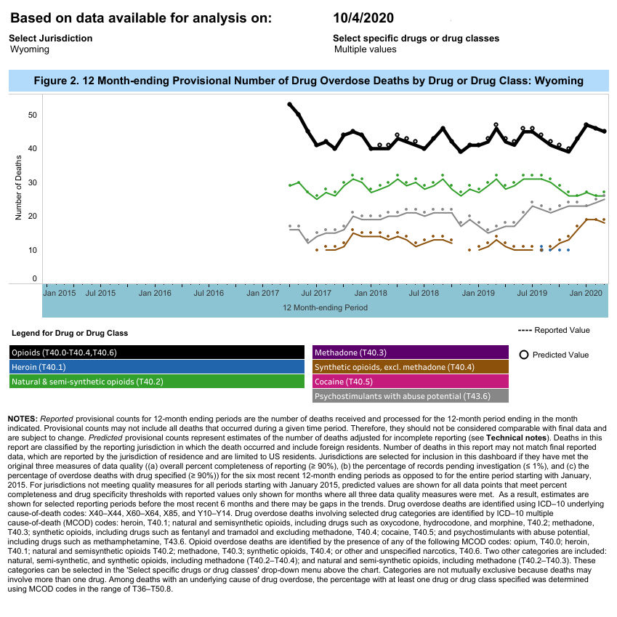
12-month provisional number of drug overdose deaths by drug or drug class, Wyoming, October 4, 2020. National Center for Health Statistics, National Vital Statistics Rapid Release, Provisional Drug Overdose Counts. https://www.cdc.gov/nchs/nvss/vsrr/drug-overdose-data.

