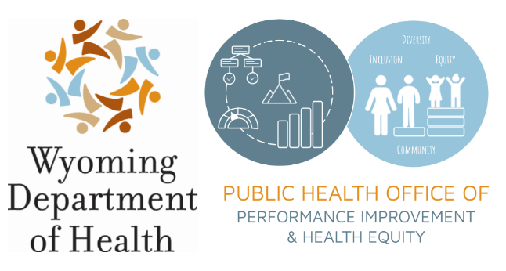
COVID-19 Health Disparities Grant:

Subrecipient and Fiscal Management Application

Key Dates
Description | Date | Time
RFA Released | 12/15/2021 | N/A
Informational/Q&A Webinar  Google Meet joining info  Video call link: https://meet.google.com/asr-vybu-qbs  Or dial: (US) +1 402-356-1106‬ PIN: 665 026 271‬# | 1/12/2022 | 1:00 - 2:30 PM MT
Q&A Responses Posted to Website | 1/17/2022 | 5:00 PM MT
Applications Due | 1/31/2022 | 5:00 PM MT
Tentative Contract Award Date | 2/15/2022 | N/A
Tentative Work Begins | 3/15/2022 | N/A

Submission
Applications shall be submitted to:

Office of Performance Improvement and Health Equity at wdh.phd-opi@wyo.gov no later than the deadline described above.

Scoring
The applications will be evaluated on the following criteria and relative weights.

FACTOR | POINTS POSSIBLE
Qualifications, experience, and capacity of the Applicant, in general; and capacity of staff to implement the proposal. | 0-30
Previous experience with similar projects, and familiarity grant-making strategy, processes, and procedures. | 0-25
Application that is clear and will meet all needs of WDH-PHD as outlined within the RFA. | 0-30
Itemized budget provided and is reasonable for delivery of services. | 0-15
TOTAL POINTS POSSIBLE | 100

Application Contents

Organization Information
Organization’s Legal Name:
Primary Contact (name, title, phone, and email):
Mailing Address:
Tax ID Number:
DUNS Number:
Website:
Name and Title of Authorized Signatory:

Organizational Capacity and Experience
Please describe the organization’s experience with grant-making and associated fiscal tracking. This should include, at minimum, a description of how the organization will meet the requirements detailed in the below bullet points. This section of the application should not exceed ten (10) pages.
- Manage the subrecipient processes, including promoting the grant opportunities, carrying out necessary outreach to eligible entities, developing application mechanisms, and reviewing and issuing grant agreements
- Disburse and track funds to eligible entities
- Assure subrecipients’ proposed activities are allowable, working with OPIHE when questions or concerns arise
- Work with subrecipients to meet the reporting requirements detailed in the Reporting Requirements section
- Work with OPIHE to provide support and technical assistance to subrecipients as necessary

Please describe the organization's capacity to effectively administer the programs required under this Request for Application (RFA). This section of the application should not exceed five (5) pages.

Please share relevant examples of the organization’s similar projects or services, or provide references for other entities your organization has provided similar services for. This section of the application should not exceed five (5) pages.

Budget
Please provide a detailed budget and justification using the template provided below.

The organization is expected to budget $14,352,000.00 for direct awards to subrecipients, as detailed by program (see Addendum A). The organization may include up to $1,248,000.00 of the available funds to support the operations, administration, and expenses incurred to administer the grant programs. The budget period will be the Effective Date of the Contract through May 31, 2023.
Budget Narrative
Salaries and Wages  Justification: | $TOTAL
Fringe Benefits  Justification: | $TOTAL
Supplies  Justification: | $TOTAL:
In-State Travel  Mileage  # of Trips # of People Total Miles Cost per Mile Amount Requested  2 (per person)  Per Diem and Lodging  Per Diem or Lodging # of People # of Units Unit Cost Amount Requested  Per Diem  Lodging  Justification: | $TOTAL
Other Categories  Item Requested # of Months Estimated Cost per Month # of Staff Amount Requested  Justification: | $TOTAL
Subrecipient Awards  Justification: | $14,352,000.00
TOTAL

