Completing your HIPAA Training Plan

Step 1.Log in to TRAIN Wyoming. Please use the Chrome browser to log in to TRAIN Wyoming at https://www.train.org/WYOMING/welcome,
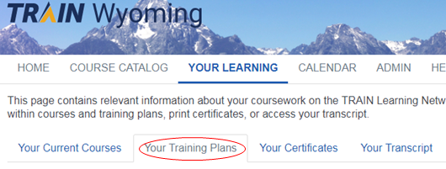
Step 2. Find your Training Plan

From the home screen, click the YOUR LEARNING tab, then the Your Training Plans tab.

Your HIPAA Training Plan will appear as a link. Click the link to begin your training.
Please note: there are different training plans according to an employee’s duties and access to Protected Health Information.
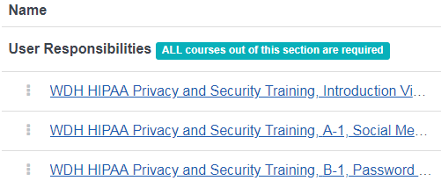
Step 3. Participate in the Course
- With your Training Plan open, click on the title of the first course on the list.
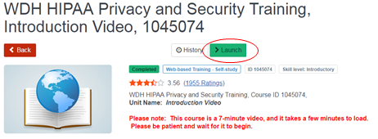
- When the course details page appears, click on the green Launch button to start the course.
Please note: There is no assessment or certificate assigned to this introduction video. Each course in the series thereafter will have an assessment, and provide a certificate which you can print if you wish. Printing the certificate is not required.

Step 4. Take the assessment
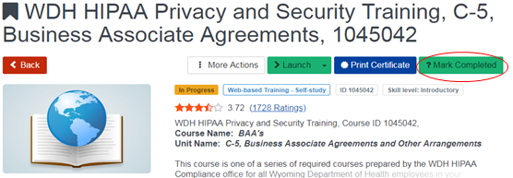
- Each of the HIPAA courses will require you to pass an assessment after you have received all of the instruction. Return to the course details page and click the green box labeled “?Mark Completed”.
- Click the green button labeled “Assessment” to begin the test. You will have up to ten attempts to pass the test. If you fail more than ten attempts, you must retake the course.
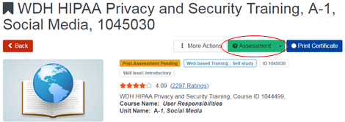

Step 5. Continue Training
Repeat Steps 2 through 4 until you have completed each course listed in your training plan.

If you get stuck, please ensure you have followed these steps carefully.

Contact wdhhrtraining@wyo.gov if you are unable to proceed with your training plan.

