Creating Your Account in TRAIN Wyoming
Please READ and FOLLOW the instructions, step-by-step, below.

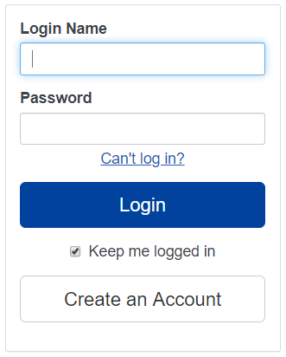
- If you already have an account in TRAIN Wyoming, please use the Chrome browser to log in to TRAIN Wyoming at https://www.train.org/WYOMING/welcome, then go to Step 4 below.
If you don’t have Chrome, you can download it here: https://www.google.com/intl/en/chrome/browser/.

If you have an account but can’t remember your password, please use the “Can't log in?” link above the Login button.
Please do not create a duplicate TRAIN account.

- Create your TRAIN Wyoming account
Open TRAIN at this address: www.TRAIN.org/Wyoming
Create your account by clicking the “Create Account” button, then complete the fields presented to you.
Choose a login name that you can remember easily. If the name is already used, TRAIN will require you to modify it.
Your email address will be your wyo.gov address if you are an employee, or your school address if you are a student.
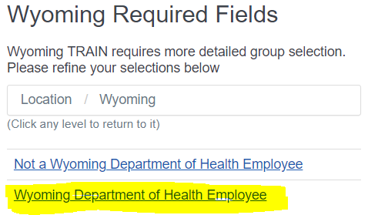

Please click the highlighted link shown in this image.
If you are NOT a Wyoming Department of Health employee, please select the other link.

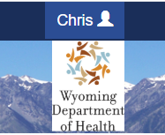
- Complete your Profile.
You must complete your profile before you take any courses in TRAIN Wyoming.
Click on your name found in the dark blue banner at the top of the window.
Click Your Profile
Click each of the sections in the left-hand navigation bar, and enter or select the requested options.

 | Select “Department of Health Employee”, then select your Division, then location as appropriate.
You MUST agree to receive email notifications. | 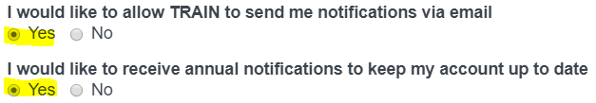
 | Please list your work telephone number. If you are issued a cell phone, you may include that as an additional number.
Please list your work or school address.
Your Postal Code will be:
Hathaway & Herschler = 82002.
Public Health Laboratory = 82007
Your Organization is the  Wyoming Department of Health. Choose your division:  Aging,  Behavioral Health,  Director’s Office,  Health Care Financing,  Public Health. | 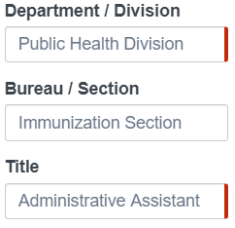  Example:
 | Input all ten digits of your employee ID number, including the leading zeros. Your supervisor or your HR staff member will provide your ID number.
 | 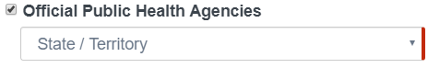
 | Please select the options that apply to you from the various categories presented.

