Community Servicers Network of Wyoming
1401 Airpot Parkway, Ste. 300
307.772.9004
info@csnowyo.org
www.csnowyo.org
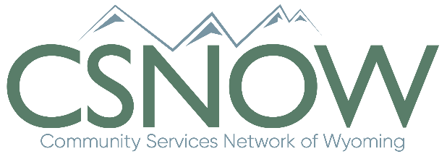
Greetings,
Poverty is an issue that effects every community in our nation. According to statistics, almost 30% of the nation live near poverty, that is, one paycheck away from being below the poverty line or in deep poverty. With such a pressing issue, there are many who seek to find solutions and help families out of these situations and make it possible for them to become self-sufficient. Through the Community Services Block Grant, Community Action Agencies are staffed with people supplying services and assistance to those in need. Those workers need support, training, and communication on a regular basis to find new solutions and be effective in their missions.
CSNOW, as the state association of community service programs, is poised to meet those needs, provide training and technical assistance, as well as advocacy for Community Action Agencies. One way we are doing this is by hosting a conference on poverty in September of 2020. To make this conference impactful for CAA’s and their staff, we are seeking sponsors for our conference to help keep costs low and supply these agencies with real value. You are receiving this letter in the hopes that you will consider joining us as a sponsor for our conference.
Along with this letter, we are including our sponsorship levels and the benefits for sponsors with the sponsorship. Please review them and let us know at the contact information above, what you are able to do. We are grateful for your generosity and partnership in combating poverty in our state.
Gratefully,
Eric Joppa
Executive Director

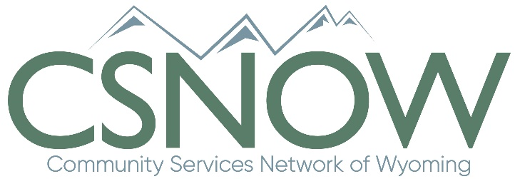
CSNOW Annual Conference
“Better Together”
Sponsorship Levels
Platinum - $5000
- 4 conference Registrations (Including Pre-conference)
- Logo on all registration swag bags
- Access to green room
- Full page ad in conference booklet
- 5 minute stage sponsor spot
- 2 Vendor booth spaces
Gold - $3000
- 3 Conference Registrations (2 pre-conference)
- ½ page ad in conference booklet
- Access to green room
- 1 minute sponsor video spot
- 1 Vendor booth space
Silver - $1500
- 2 Conference Registrations (1 pre-conference)
- ¼ page ad in conference booklet
- Access to green room
Bronze - $500
- 1 Conference Registration
- Logo in conference booklet

