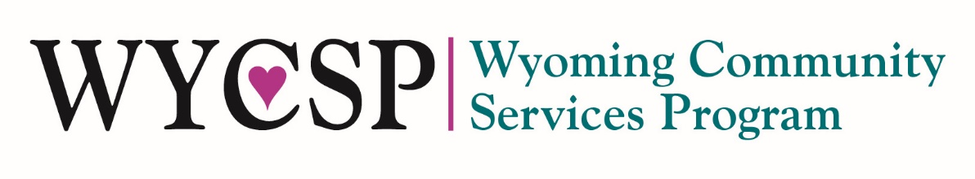
Community Services Block Grant (CSBG)
FY2021 Community Initiative Status Form

Program Information
Grantee Name: | Click to enter text | Sub-Grantee Name (if applicable): | Click to enter text
Initiative Name: | Click to enter text | Initiative Year: | Choose an item.
CSBG Allocation for Initiative: | $ Click to enter amount | Partner/Other Funder(s) Contribution: | $ Click to enter amount

*Submission of this form should occur at the end of the fiscal year, but October 10th, with final Expenditure Reports related to the Community-Level Initiative, and any reportable outcomes tracked in CAP60.
Phases of Community-Level Transformations
☐ | Formative Phase – SUBMIT QUESTIONS 1-4 TO CSP
 | This phase refers to any community-level efforts that are in the early stages of development and may include community needs assessment work, focus groups, consensus-building meetings, “brainstorming” work with multiple organizational stakeholders to identify issues and discuss potential solutions, and early planning meetings to identify potential collaborative activities.
☐ | Formal Planning Phase – SUBMIT QUESTIONS 1-11 TO CSP
 | This phase refers to a work process in which the eligible entity is actively engaged in a community-level planning effort in which there is general agreement upon one or more cause or condition of poverty in the community as well as a commitment by the eligible entity and any necessary community partners to identifying and implementing strategies to address the identified issues. The participating organizations may have identified initial resources to support the planning effort and at minimum have committed necessary staff time for the planning and design of new community-level solutions.
☐ | Active Implementation Phase – SUBMIT QUESTIONS 1-15 TO CSP
 | During this phase of work the eligible entity and any organizational partners have launched necessary working groups, developed a formal plan of action with an ultimate goal, and established shared metrics (indicators, measurements, and a shared approach to collecting and analyzing performance data). While organizational partners may be working to identify and secure additional resources for the effort, there is an initial commitment of resources, identification of organizational roles, and at least one agreed-upon strategy for accomplishing common goals. The eligible entity is an active participants and has a clear role in implantation efforts.
☐ | Maturity Phase – COMPLETE THE FORM AND SUBMIT TO CSP
 | When an eligible entity and any community partners have successfully implemented a community-level strategy, an effort may reach a “maturity level” in which the initial or ultimate goal(s) has been accomplished and the ongoing effort is focused on sustaining its initial outcomes. For example, an effort to address a shortage of affordable housing may have reached its initial goal(s) of creation of a specified number of affordable housing units or a job creation effort may have successfully created new employment opportunities.

Formative | 1. | Initiative Name | Click here to enter text.
 | 2. | Initiative Year | Choose an item.
 | 3. | Problem Identification | Click here to enter text.
 | 4. | Goal Statement | Click here to enter text.
Formal Planning | 5. | CNPI Domain(s)  *You must have at least one CNPI outcome in the domain(s) listed here. | ☐ CNPI 1: Employment  ☐ CNPI 2: Education and Cognitive Development  ☐ CNPI 3: Infrastructure and Asset Building  ☐ CNPI 4: Housing  ☐ CNPI 5: Health and Social/Behavioral  ☐ CNPI 6: Civic Engagement and Community Involvement
 | 6. | Expected Outcomes – CNPI(s)  *Your CNPIs must match the domain(s) selected above. | Click here to enter text.
 | 7. | Identified Community | Choose an item.
 | 8. | Expected Duration | Choose an item.
 | 9. | Partnership Type | Choose an item.
 | 10. | Partners | Click here to enter text.
 | 11. | Strategy(ies) | Click here to enter text.
Active Implementation | 12. | Progress on Outcomes/Indicators | Choose an item.
 | 13. | Impact of Outcomes/Indicators | Click here to enter text.
 | 14. | Outcomes/Indicators to Report | Click here to enter text.
 | 15. | Final Status | Choose an item.
Maturity | 16. | Lessons Learned | Click here to enter text.

