Influenza Virus Collection Protocol
2019-20 Influenza Season

Sentinel Site Kits

Specimen Collection:
Specimen should be collected within 3 days of onset of symptoms.
Use only Dacron swabs provided. (Do not use wood or calcium alginate swabs.)
Preferable Specimen: Nasopharyngeal Swab
Acceptable: Nasal swab, pharyngeal swab, and nasal aspirate/wash
Collect swab (or aspirate) and place in viral transport medium.
Break shafts of swabs to permit closure of tube with screw cap.
Screw cap on tube securely to avoid leakage.
Label each specimen with patient’s name and collection date.
Refrigerate specimen(s) until ready to ship.

Shipping:
Mail specimens only Monday-Thursday using overnight delivery or state courier.
Package each specimen individually in a biohazard bag with absorbent paper.
Complete the request form entirely and place in the biohazard bag pocket.
Multiple specimens collected the same day may be shipped in the same shipping container.
Place frozen ice packs in with the specimens to maintain at 4ºC.
Close container and seal with tape.
If sending by courier, write WPHL on the side of the box.
Ensure that Courier Service knows the specimens require refrigerated transportation.

NOTE: Store all transport media according to package instructions.
Store collected specimens at 4ºC until shipment!
SPECIMENS MUST ARRIVE AT THE LABORATORY WITHIN 24-48 HOURS OF COLLECTION.
*The only exception is when specimens are collected on Friday or the weekend, refrigerate
the specimens until it can be mailed on Monday.

Flu forms are available on our website at https://health.wyo.gov/publichealth/lab/microcollect/
For collection training, please go to www.jointcommission.org/siras

If you have any questions concerning collection or shipment, please call 307-777-7431 and ask for the Influenza testing personnel.
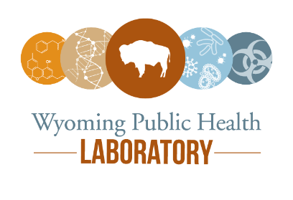
Public Health Division | Public Health Laboratory
208 South College Drive Cheyenne, Wyoming 82007
Phone (307) 777-7431 | Fax (307) 777-6422

