Date and Time: February 26, 2019, 2:30 – 4:00 PM
Conference Line: 1-877-278-2734 Passcode: 154416

Agenda Items |  | Summary of Discussion
- Welcome and Introductions – Anita |  | A welcome was extended to the callers and all other staff present were acknowledged.
- State of Wyoming Long Term Care (LTC) Ombudsman program – Lindsay Hruby |  | See attached PowerPoint and FAQs. Also resending brochure and map.
- Plan of Care changes, effective with 03/01/2019 plans |  | There have been system changes made to the EMWS, effective with 03/01/2019 plans of care and forward. CMs will no longer be required to choose which service model (Agency, Participant Directed, or ALF) the participant is receiving their services under. The selections made in the Goals section will now be used to determine which service model the participant is receiving services under. Also, CMs will manually add Case Management services and will be expected to adjust the daily rate that matches the service.
- Qualis contract |  | The Community Choices Waiver (CCW) program has contracted with Qualis to provide oversight of skilled nursing visit authorizations under the CCW program.  Beginning April 1, 2019, CCW direct service provider agencies, providing skilled nursing services under the waiver, will submit doctor’s orders and required documentation to the Qualis team for review. Qualis will review and approve or deny requests based on medical necessity of the service(s) for the participant, other program participation better suited to meet the needs of the patient, and guidelines provided by the CCW program.  Once Qualis has completed their review and has made a determination, they will provide a written notification to the requesting agency and that notification will be provided to the CCW case manager in lieu of a doctor’s order. As of April 1, doctor’s orders will no longer be accepted for skilled nursing services on plan of care submissions or modifications to add skilled nursing services.  Training sessions are being provided by Qualis and are available for CMs who wish to attend to gain a better understanding of the process. You may register through the links in the body of this email.
- PA inquiry portal |  | The PA inquiry and print functionality in the Provider portal is now active. Approved PAs whose expiration date is a year in the future will be available on the portal. Tutorial with screen shots attached.
- EMWS password resets - Julie |  | EMWS users who need a password reset, should first attempt to reset their own password using the link on the Gateway login page by clicking on “Forgot Password?”.  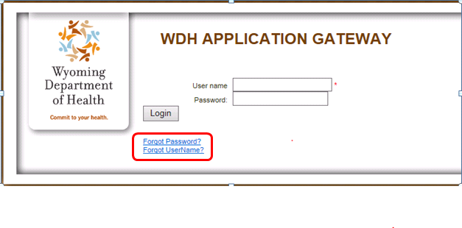  If the issue is something other than password reset, or if users have tried and are still having difficulty, please submit a request to the EMWS Helpdesk email so that assistance can be provided more quickly. The EMWS Helpdesk email address is ccw.emws.helpdesk@wyo.gov
- FREE SNAP webinar |  | As an informational resource from the National Center on Law & Elder Rights, CCW case managers are being afforded an opportunity to log into a FREE webinar called Legal Basics: Supplemental Nutrition Assistance Program (SNAP) on Tuesday, March 12, 2019 at 12:00 p.m. Register at https://register.gotowebinar.com/register/8467653902518912515?source=Salsa&eType=EmailBlastContent&eId=91fdeaa0-bbd3-440d-83c4-33913254de02  The webcast is designed to help viewers:  - Understand who the SNAP program serves;  - Identify barriers to enrollment that seniors face and ways to overcome those barriers;  - Outline the process to determine SNAP eligibility; and  - Identify common problems that may require an appeal.  Due to the high volume of anticipated participants, computer audio will be the only option to listen to the presentation. No telephone call-in number will be provided. Please plan accordingly. Closed captioning will be available on this webcast. A link with access to the captions will be shared through GoToWebinar's chat box shortly before the webcast start time.
- Q & A
Next Call | - April 23, 2019 2:30 – 4:00 p.m.

Community-Based Services Unit
6101 Yellowstone Road, Suite 210
Cheyenne, WY 82001
Fax: 777-8685
Participant Application Support Line: 1-855-203-2823
EMWS Help Desk: ccw.emws.helpdesk@wyo.gov
Administrator | Tyler Deines  Community-Based Services Unit | tyler.deines@wyo.gov | 777-2485
Benefits Administration | James Hruby  Programs & Benefits Manager | james.hruby1@wyo.gov | 777-7366
 | Anita Fox  Case Management & Participant Support Coordinator | anita.fox@wyo.gov | 777-8230
Program Performance | Alice Zimmerman  Program Evaluation & Outcomes Manager | alice.zimmerman@wyo.gov | 777-7861
 | Jeff Oliver  Quality Assurance Coordinator | jeff.oliver2@wyo.gov | 777-1913
 | Sherry Mitchell  Assessments Coordinator | sherry.mitchell1@wyo.gov | 777-5029
Business & Operations | Julie Lacey  Contracts & Operations Manager | julie.lacey1@wyo.gov | 777-5099
 | Lauri Million  Program Support Specialist | lauri.million@wyo.gov | 777-5600

