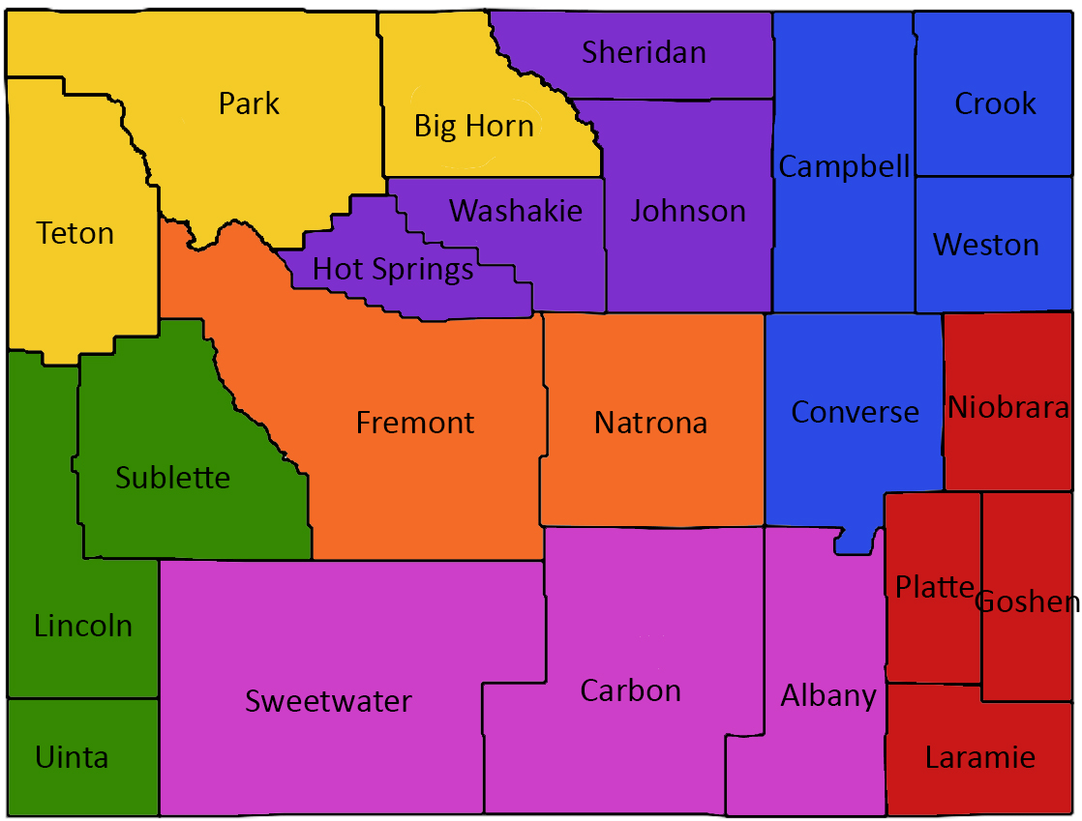

Region 1 Yellow  Lindsay Martin  lindsay.martin@wyo.gov  307-777-8034  Region 2 Purple  Sarah Spafford  sarah.spafford@wyo.gov  307-777-2923  Region 3 Blue  Ashley Provencio  Ashley.provencio1@wyo.gov  307-777-3357  Region 4 Red  Erica Mathews  erica.mathews@wyo.gov  307-777-6463 | Region 5 Pink  Missie Payne  melissa.payne1@wyo.gov  307-777-5017  Region 6 Green  Hannah Eck  hannah.eck@wyo.gov  307-777-6541  Region 7 Orange  Joe D’Eufemia  joseph.deufemia@wyo.gov  307-777-3744  Invoicing  wdh.prevention@wyo.gov

