WIPAG
WY Infection Prevention Orientation Manual
Table of Contents

WIPAG
October 2014

Table of Contents

Section 1: Introduction

Section 2: Infection Preventionist Job Description

Section 3: Authority of the Infection Preventionist

Section 4: Committee Leadership and Membership

Section 5: Surveillance

Section 6: Outbreak Management

Section 7: Standard and Transmission-Based Precautions

Section 8: Medical Instrument and Device Reprocessing

Section 9: Environmental Services

Section 10: Laboratory

Section 11: Microbiology

Section 12: Antimicrobial Stewardship

Section 13: Current Infection Prevention Issues in Dialysis

Section 14: Construction and Renovation

Section 15: Emergency Preparedness

Section 16: Quality Assurance and Performance Improvement

Section 17: Regulatory Compliance in Infection Control

Section 18: Patient Engagement

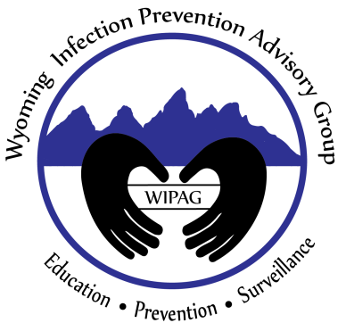

WIPAG welcomes your comments and feedback on these sections.
For comments or inquiries, please contact:

Emily Thorp, MS, Healthcare-Associated Infection (HAI) Prevention Coordinator
Infectious Disease Epidemiology Unit,
Public Health Sciences Section, Public Health Division
Wyoming Department of Health
6101 Yellowstone Road, Suite #510
Cheyenne, WY 82002
Tel: 307-777-8634 Fax: 307-777-5573
Email: emily.thorp@wyo.gov
Website: www.health.wyo.gov/phsd/epiid/HAIgeneral.html

October 2014

